A REPORT

ON
SMART CLASSROOM BEHAVIOR DETECTION USING YOLOv8

Submitted by

Ms. B S VANISHA BABU - 20241CSG0007

Under the guidance of,
Dr./Mr./Ms. Reviewer 1
Dr./Mr./Ms. Reviewer 2

in partial fulfillment for the award of the degree of
BACHELOR OF TECHNOLOGY

IN

COMPUTER SCIENCE AND TECHNOLOGY
(ARTIFICIAL INTELLIGENCE AND MACHINE LEARNING)
AT



PRESIDENCY UNIVERSITY
BENGALURU
AUGUST 2026

PRESIDENCY UNIVERSITY

PRESIDENCY SCHOOL OF COMPUTER SCIENCE AND ENGINEERING


CERTIFICATE

This is to certify that the report of CSE7000 – Internship on "Smart Classroom Behavior Detection using YOLOv8" being submitted by “B S VANISHA BABU” bearing roll number “20241CSG0007” in partial fulfillment of the requirement for the award of the degree of Bachelor of Technology in COMPUTER SCIENCE AND TECHNOLOGY (ARTIFICIAL INTELLIGENCE AND MACHINE LEARNING) is a bonafide work carried out under our supervision.

Dr/Mr/Ms. <Reviewer Name 1>  Designation  PSCS  Presidency University | Dr/Mr/Ms. <Reviewer Name 2>  Designation  PSCS  Presidency University | Mr. Saptarsi Sanyal  PSCS  Presidency University

Dr. Bhuvaneshwari Patil  School level coordinator  PSCS  Presidency University | Dr. Pallavi R  HOD  PSCS  Presidency University | Dr. Duraipandian N  Dean – PSCS & PSIS  Presidency University

PRESIDENCY UNIVERSITY

PRESIDENCY SCHOOL OF COMPUTER SCIENCE AND ENGINEERING

DECLARATION

I hereby declare that the work, which is being presented in the report entitled "Smart Classroom Behavior Detection using YOLOv8" in partial fulfillment for the award of Degree of Bachelor of Technology in COMPUTER SCIENCE AND TECHNOLOGY (ARTIFICIAL INTELLIGENCE AND MACHINE LEARNING) is a record of my own investigations carried under the guidance of Reviewer Name1, Designation and Reviewer Name2, Designation, Presidency School of Computer Science and Engineering, Presidency University, Bengaluru.

I have not submitted the matter presented in this report anywhere for the award of any other Degree.

Name : B S Vanisha Babu
Roll No : 20241CSG0007
Signature of the Student :

INTERNSHIP COMPLETION CERTIFICATE

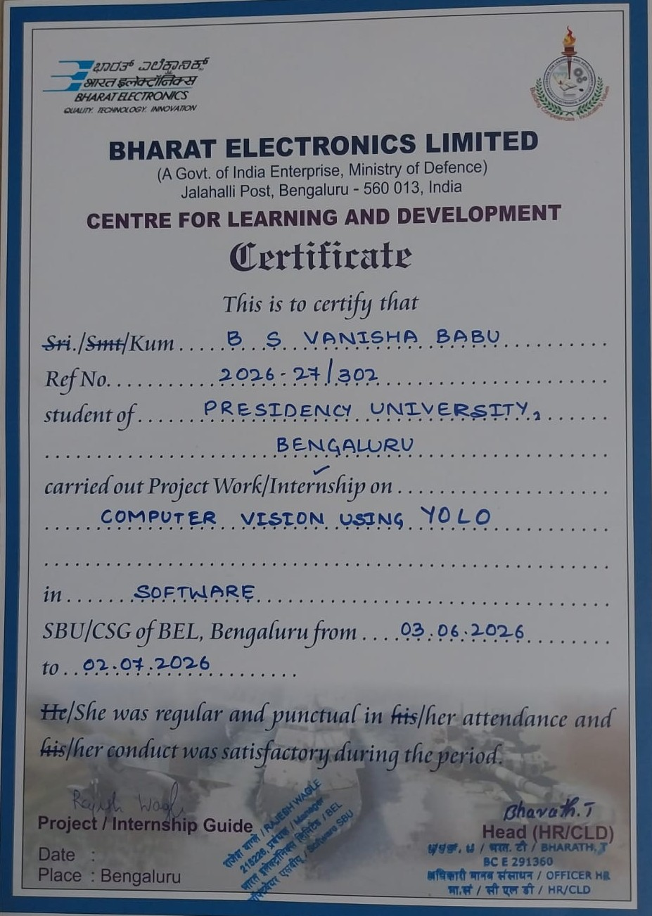

ACKNOWLEDGEMENTS

First of all, I indebted to the GOD ALMIGHTY for giving me an opportunity to excel in our efforts to complete this internship on time.
I express sincere thanks to our respected Dean Dr. Duraipandian N, Presidency School of Computer Science and Engineering & Presidency School of Information Science, Presidency University for getting us permission to undergo the internship.
I express heartfelt gratitude to our beloved Dr. Pallavi R, Head of the Department, Presidency School of Computer Science and Engineering, Presidency University, for rendering timely help in completing this internship successfully.
I would like to express my sincere gratitude to Bharat Electronics Limited (BEL), Bengaluru, especially the officials, project guide, and technical staff of the Software Division, for providing me with the opportunity to undergo this internship. Their constant guidance, encouragement, and technical support helped me gain practical knowledge in Computer Vision using YOLO and successfully complete my internship projec
I am greatly indebted to my reviewers Dr./Mr.Ms. Name, Designation and Dr./Mr.Ms. Name, Designation, Presidency School of Computer Science and Engineering, Presidency University for their inspirational guidance, and valuable suggestions and for providing a chance to express technical capabilities in every respect for the completion of the internship work.
I would like to convey gratitude and heartfelt thanks to the Internship Coordinator Dr. Bhuvaneshwari Patil and Program Internship Coordinator Mr. Saptarsi Sanyal. I also thank my family and friends for the strong support and inspiration they have provided us in bringing out this internship.

Name of the Student : B S Vanisha Babu
Roll No : 20241CSG0007

ABSTRACT

Internships play an important role in bridging the gap between classroom learning and practical industrial experience. They provide students with an opportunity to apply theoretical knowledge to real-world problems while learning new technologies and professional work practices. As part of my Bachelor of Technology curriculum in Computer Science and Technology (Artificial Intelligence and Machine Learning), I successfully completed a 30-day internship at Bharat Electronics Limited (BEL), Bengaluru, in the Software Division from 03 June 2026 to 02 July 2026.
During the internship, I worked in the field of Computer Vision using YOLO and gained practical exposure to deep learning-based object detection systems. The main objective of the internship was to understand how Artificial Intelligence can be used to solve real-world problems through image and video analysis. Throughout the internship, I learned about the complete workflow involved in developing an object detection model, starting from data collection and preprocessing to model training, testing, evaluation, and deployment.
As part of my internship work, I developed a project titled "Smart Classroom Behavior Detection using YOLOv8." The purpose of this project was to detect and classify different student behaviours inside a classroom automatically using Computer Vision techniques. Traditional classroom monitoring depends entirely on teachers or supervisors, which becomes difficult in large classrooms. An automated behaviour detection system can assist in monitoring student activities more efficiently and help in understanding classroom engagement.
The project was implemented using Python as the programming language and YOLOv8 (You Only Look Once Version 8) as the object detection model. Other technologies used during the implementation included OpenCV for image and video processing, Google Colab for model training, and Roboflow for dataset preprocessing and management. A publicly available classroom behaviour dataset was used for training and testing the model.
The developed system was trained to identify eight different classroom behaviours, namely Hand Raise, Reading, Writing, Sleeping, Standing, Looking Forward, Using Device, and Turning Head. The dataset was first analysed and preprocessed before training the model. After preprocessing, the dataset was divided into training, validation, and testing sets. The YOLOv8 model was then trained for multiple epochs to improve its detection accuracy. After successful training, the model was tested on both images and videos to evaluate its performance under different classroom scenarios.
The project produced encouraging results and was able to detect multiple student behaviours with good accuracy. Along with behaviour detection, I also implemented behaviour counting and generated simple analytics based on the detected activities. These results demonstrated how Artificial Intelligence and Computer Vision can be effectively applied in educational environments to automate classroom observation and improve monitoring efficiency.
Apart from technical knowledge, this internship also helped me understand industrial work culture, project planning, documentation practices, teamwork, and problem-solving techniques. While working on the project, I faced several practical challenges such as dataset preparation, model optimization, handling training errors, and improving detection performance. Overcoming these challenges enhanced my analytical thinking and strengthened my understanding of Machine Learning and Deep Learning concepts.
This internship provided me with valuable hands-on experience in implementing a complete Computer Vision project from start to finish. It also improved my programming skills, technical knowledge, and confidence in working with Artificial Intelligence technologies. The knowledge gained during this internship will be beneficial for my future academic projects, research work, and career in the field of Artificial Intelligence and Machine Learning.
In conclusion, the internship at Bharat Electronics Limited was a highly enriching learning experience. It enabled me to understand the practical applications of Computer Vision and YOLO-based object detection systems while exposing me to an industrial working environment. The project "Smart Classroom Behavior Detection using YOLOv8" successfully demonstrated the use of Artificial Intelligence for automated classroom monitoring and laid a strong foundation for developing more advanced intelligent surveillance and educational support systems in the future.
Keywords: Artificial Intelligence, Computer Vision, YOLOv8, Object Detection, Deep Learning, Python, OpenCV, Roboflow, Smart Classroom, Behaviour Detection.

Introduction
Artificial Intelligence (AI) has become one of the most influential technologies of the 21st century, transforming the way people interact with machines and enabling computer systems to perform tasks that traditionally required human intelligence. AI has found applications in numerous fields such as healthcare, finance, manufacturing, transportation, agriculture, education, and defence. With continuous advancements in computing power and the availability of large datasets, Artificial Intelligence has become an essential part of modern technological solutions, improving efficiency, accuracy, and automation across various industries.
One of the most rapidly growing branches of Artificial Intelligence is Computer Vision, which focuses on enabling computers to interpret, analyse, and understand visual information from images and videos. Computer Vision combines image processing techniques with Machine Learning and Deep Learning algorithms to recognise objects, detect patterns, classify images, and analyse movements. Today, Computer Vision is widely used in applications such as facial recognition, medical image analysis, autonomous vehicles, industrial inspection, surveillance systems, traffic monitoring, and smart educational systems.
Among the different Computer Vision tasks, object detection plays a significant role because it enables a system not only to identify an object but also to determine its location within an image by drawing bounding boxes around detected objects. Over the years, several object detection algorithms have been developed, including R-CNN, Fast R-CNN, Faster R-CNN, SSD (Single Shot Detector), and the YOLO (You Only Look Once) family of models. These models have significantly improved the speed and accuracy of real-time object detection.
YOLO (You Only Look Once) is one of the most popular object detection algorithms because it performs object localisation and classification in a single forward pass through the neural network, making it considerably faster than traditional methods. The latest version, YOLOv8, developed by Ultralytics, offers improved detection accuracy, faster inference speed, better training performance, and support for multiple computer vision tasks, including object detection, image classification, segmentation, and pose estimation. These advantages make YOLOv8 an excellent choice for developing real-time intelligent monitoring systems.
The education sector has also begun adopting Artificial Intelligence to improve teaching, learning, and classroom management. In conventional classrooms, monitoring the behaviour and participation of every student throughout an entire class can be difficult, particularly when the class size is large. Continuous manual observation requires significant effort and may not always provide accurate or consistent information about student engagement. Intelligent classroom monitoring systems based on Computer Vision can assist teachers by automatically detecting and analysing student activities, enabling better classroom management and improved educational outcomes.
Smart classroom behaviour detection is one such application of Computer Vision that focuses on identifying different student activities from classroom images or videos. By recognising behaviours such as reading, writing, hand raising, standing, sleeping, looking forward, using electronic devices, and turning the head, an intelligent monitoring system can provide valuable insights into classroom participation and student attentiveness. Such systems can support teachers by reducing manual observation while generating useful behavioural statistics for educational analysis.
As part of the academic curriculum of the Bachelor of Technology programme in Computer Science and Technology (Artificial Intelligence and Machine Learning) at Presidency University, I successfully completed a 30-day internship at Bharat Electronics Limited (BEL), Bengaluru, in the Software Division. The internship provided practical exposure to the industrial applications of Artificial Intelligence and Computer Vision while allowing me to work on real-world object detection techniques using the YOLO framework.
During the internship, I worked on a project titled "Smart Classroom Behavior Detection using YOLOv8." The primary objective of the project was to develop an automated system capable of detecting and classifying different classroom behaviours using deep learning techniques. The project was implemented using Python, YOLOv8, OpenCV, Google Colab, and Roboflow. A publicly available classroom behaviour dataset containing annotated images was used for training, validation, and testing the model.
The system was designed to recognise eight different classroom behaviours: Hand Raise, Reading, Writing, Sleeping, Standing, Looking Forward, Using Device, and Turning Head. The project involved several stages, including dataset preprocessing, model training, validation, performance evaluation, and behaviour detection on images and videos. The trained model demonstrated effective performance in recognising classroom activities and highlighted the practical use of Artificial Intelligence in smart education systems.
This internship not only enhanced my technical knowledge of Computer Vision, Deep Learning, and object detection but also helped me understand industrial work culture, project planning, software development practices, documentation standards, and problem-solving techniques. It provided valuable practical experience in applying theoretical concepts to real-world applications and strengthened my confidence in developing AI-based solutions.
The following sections of this report describe the objectives of my internship, the work carried out during the internship, the results obtained, and the overall learning experience gained at Bharat Electronics Limited.

Figure 1.1: Artificial Intelligence Hierarchy

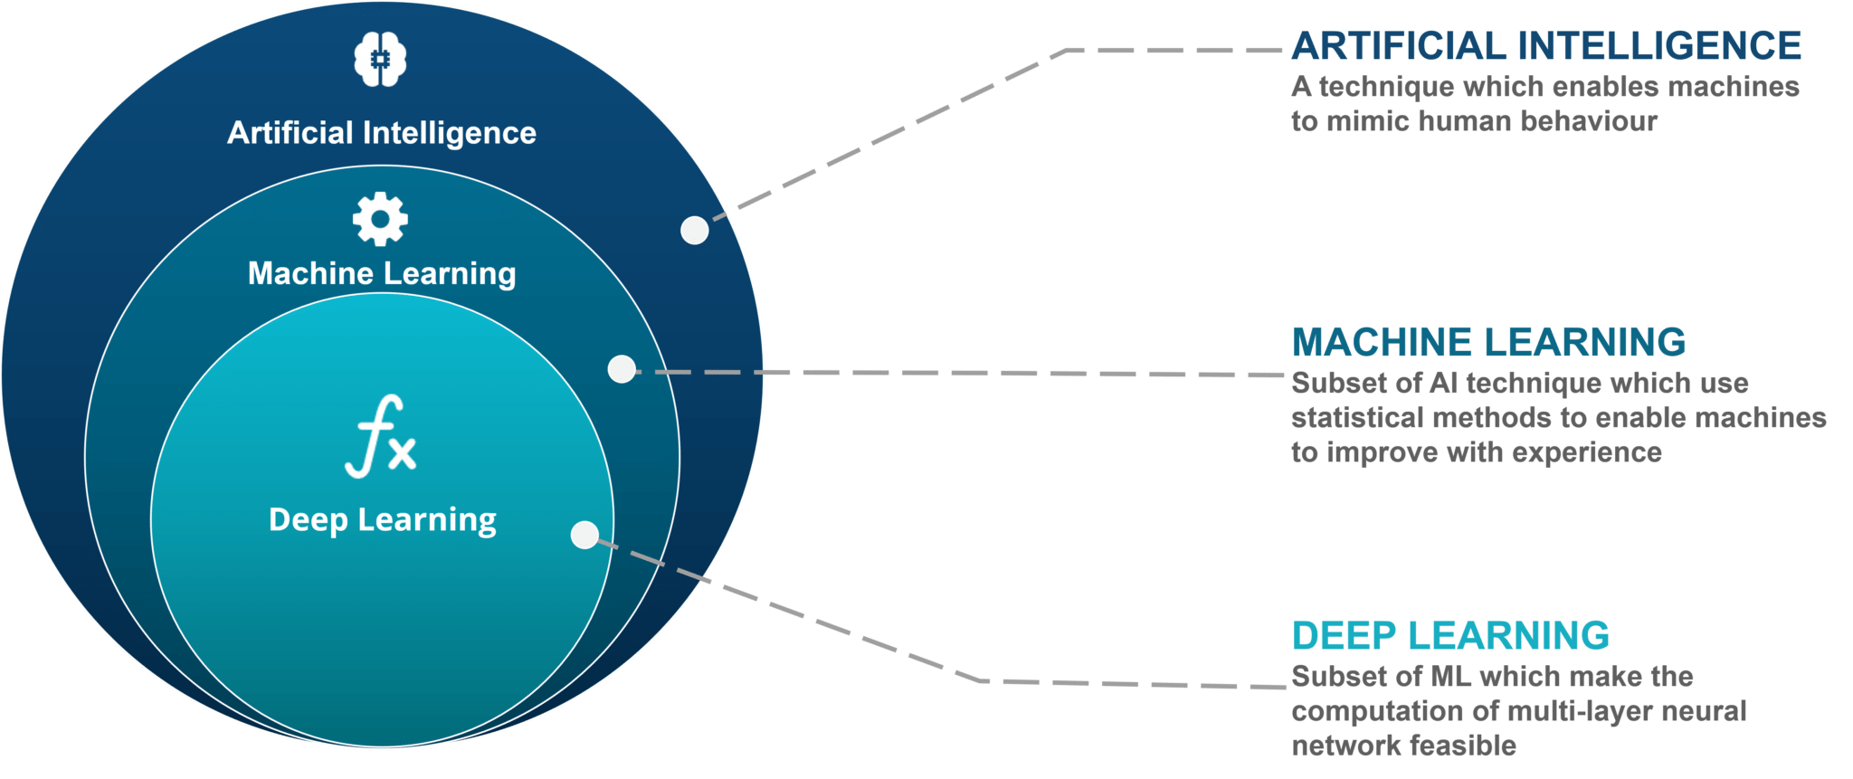

Objective
The primary objective of this internship was to gain practical knowledge and industrial exposure in the field of Computer Vision using YOLO while understanding how Artificial Intelligence and Deep Learning techniques are applied to solve real-world problems. The internship at Bharat Electronics Limited (BEL), Bengaluru, provided an opportunity to enhance technical skills, improve problem-solving abilities, and gain hands-on experience in developing AI-based applications.
The specific objectives of the internship and the project are as follows:
- To understand the fundamentals of Artificial Intelligence, Machine Learning, Deep Learning, and Computer Vision.
- To gain practical exposure to the industrial working environment and software development practices at Bharat Electronics Limited (BEL).
- To study and implement the YOLOv8 (You Only Look Once Version 8) object detection algorithm for real-time behaviour detection.
- To collect, preprocess, and prepare a classroom behaviour dataset suitable for training an object detection model.
- To develop a Smart Classroom Behavior Detection System capable of detecting multiple student behaviours from classroom images and videos.
- To identify and classify eight classroom behaviours: Hand Raise, Reading, Writing, Sleeping, Standing, Looking Forward, Using Device, and Turning Head.
- To train, validate, and evaluate the YOLOv8 model using standard object detection performance metrics such as Precision, Recall, and Mean Average Precision (mAP).
- To perform behaviour detection on images and videos and analyse the performance of the trained model.
- To understand the practical applications of Computer Vision in educational environments and explore its potential for automated classroom monitoring.
- To improve programming, analytical thinking, documentation, and technical presentation skills through the successful completion of the internship project.
The successful completion of these objectives helped me strengthen my theoretical knowledge through practical implementation and provided valuable experience in applying Artificial Intelligence and Computer Vision techniques to real-world industrial application.

Figure 1.2: YOLOv8 Object Detection Example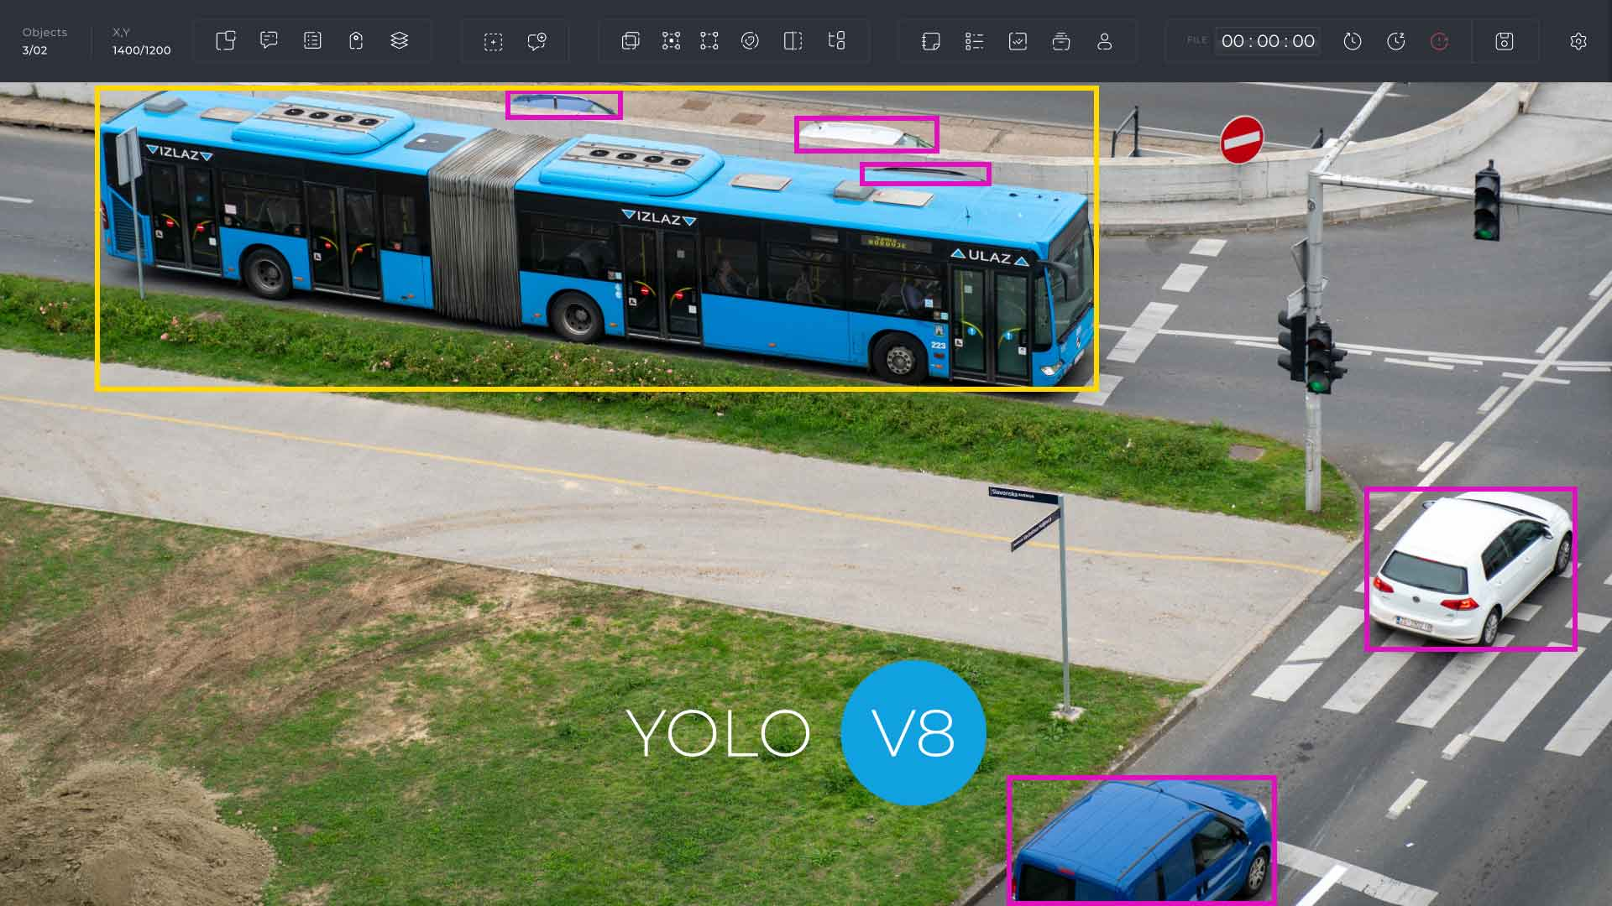

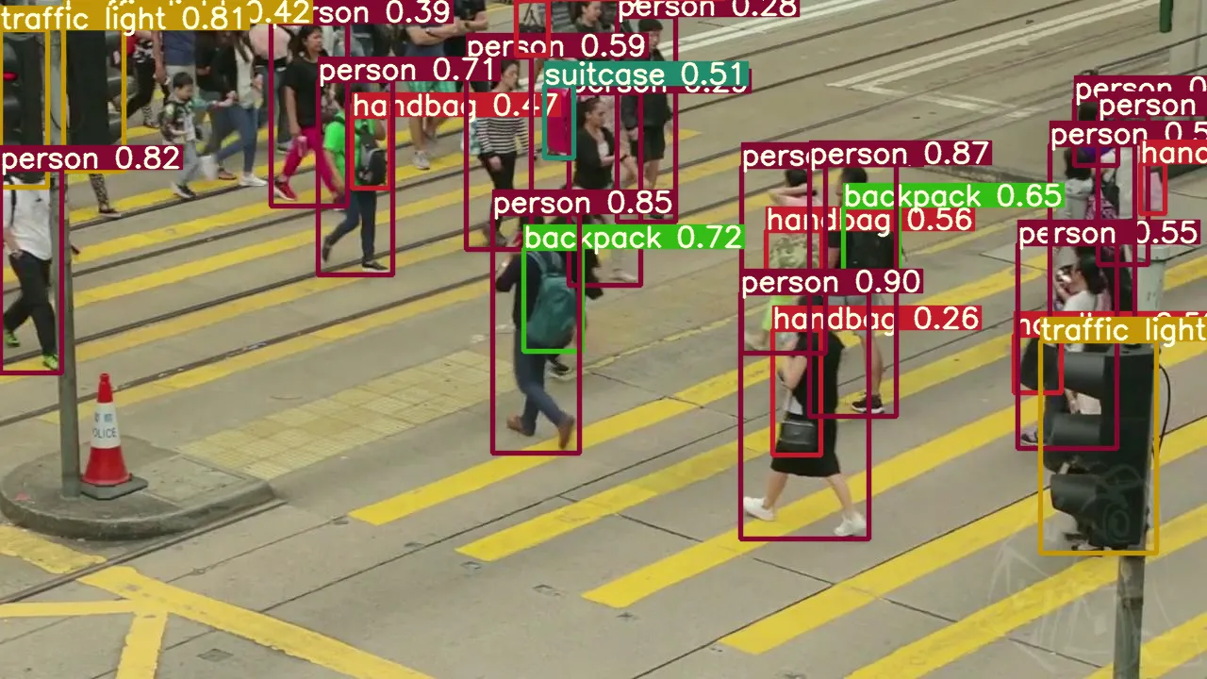

Work progress
3.1 About the Organization
Bharat Electronics Limited (BEL) is a premier Public Sector Undertaking (PSU) under the Ministry of Defence, Government of India. Established in 1954, BEL specializes in the design, development, manufacturing, and supply of advanced electronic products and systems for defence, aerospace, homeland security, and civilian applications. Over the years, BEL has played a significant role in strengthening India's indigenous defence capabilities by developing state-of-the-art technologies and supporting national strategic programs.
The Bengaluru unit of BEL houses several research, development, manufacturing, and training facilities. It also includes the Centre for Learning and Development (CLD), which provides internship opportunities to engineering students. These internships enable students to gain practical exposure to industrial work environments, emerging technologies, and professional software development practices.
As part of my Bachelor of Technology curriculum, I completed a 30-day internship at Bharat Electronics Limited, Bengaluru, in the Software Division. During the internship, I worked in the domain of Computer Vision using YOLO, where I gained hands-on experience in object detection, dataset preparation, deep learning model training, testing, and performance evaluation.
The internship allowed me to understand how Artificial Intelligence techniques are applied in practical applications while improving my programming skills, analytical thinking, and technical documentation abilities.
Figure 1.3 BEL Logo & Figure 1.4 BEL Bengaluru Campus

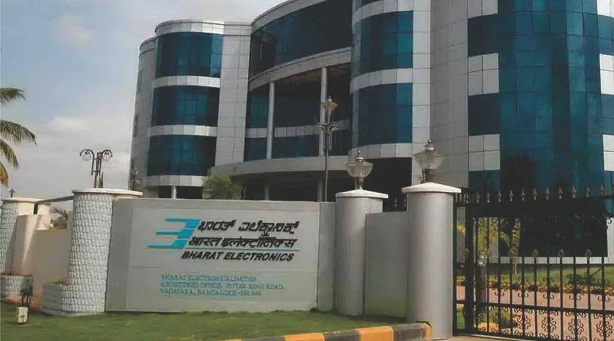

1.5 Internship Domain
The internship was conducted in the field of Computer Vision, a rapidly growing branch of Artificial Intelligence that enables computers to understand and analyse images and videos.
The primary focus of the internship was to study the YOLO (You Only Look Once) object detection framework and understand its implementation for real-time applications.
Throughout the internship, I learned the complete workflow involved in developing an object detection model, including:
- Understanding object detection concepts
- Studying the YOLO architecture
- Dataset preprocessing
- Model training
- Validation
- Testing
- Performance evaluation
This practical exposure helped me understand how Computer Vision technologies are used in real-world industrial applications.

Figure 2.1 Computer Vision Workflow

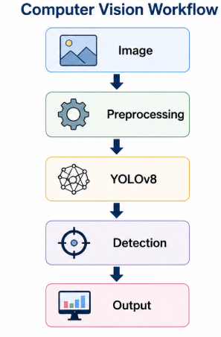

Figure 2.2 Project Workflow

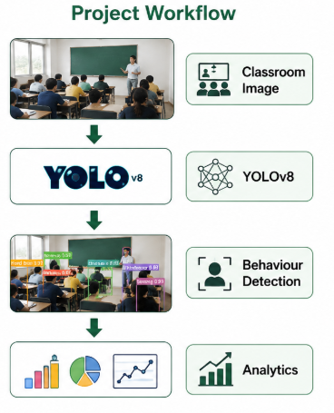
2.3 Project Title
The project assigned during the internship was:
Smart Classroom Behavior Detection using YOLOv8
The objective of the project was to develop an intelligent classroom monitoring system capable of automatically detecting different student behaviours from classroom images and videos.
The system was trained to identify the following classroom behaviours:
- Hand Raise
- Reading
- Writing
- Sleeping
- Standing
- Looking Forward
- Using Device
- Turning Head
The project demonstrates how Artificial Intelligence and Computer Vision can support smart educational environments by automating and generating behavioural insights.

2.4 Understanding the Problem
Traditional classroom monitoring depends entirely on teachers or supervisors to observe students manually. In classrooms with a large number of students, continuous monitoring becomes difficult and time-consuming. Manual observation may also result in inconsistencies, making it challenging to accurately analyse student participation and engagement.
To overcome these limitations, the internship project focused on developing an automated behaviour detection system using Computer Vision. By analysing classroom images and videos, the system can identify multiple student activities in real time and provide useful information regarding classroom behaviour.
Such systems can support teachers in monitoring classroom activities efficiently while reducing manual effort.

2.5 Software and Tools Used
The implementation of the project required various software tools and libraries.
Software / Tool | Purpose
Python | Programming language used for project implementation
Google Colab | Cloud-based environment for model training
YOLOv8 | Deep learning model for object detection
OpenCV | Image and video processing
Roboflow | Dataset preprocessing and management
Kaggle Dataset | Smart Classroom Behaviour Dataset
GitHub | Project version control and source code management
Each of these tools played an important role during different stages of the internship, from dataset preparation to model development and testing.

Figure 3.1 Software & Tools

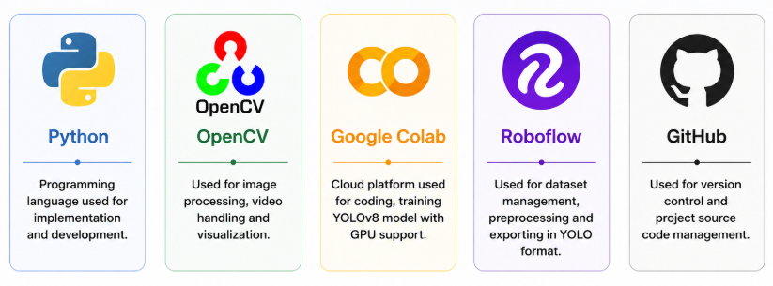

3.2 Learning the YOLO Framework
During the initial phase of the internship, I studied the fundamentals of the YOLO object detection algorithm and understood its advantages over traditional object detection methods.
Unlike conventional algorithms that perform object localization and classification separately, YOLO performs both tasks simultaneously in a single forward pass through the neural network. This makes YOLO highly efficient for real-time applications.
The latest version, YOLOv8, offers several improvements such as:
- Higher detection accuracy
- Faster inference speed
- Better training efficiency
- Simplified implementation
- Support for multiple Computer Vision tasks
Understanding the architecture and workflow of YOLOv8 provided the foundation for implementing the Smart Classroom Behavior Detection system.

3.3 Dataset Collection
A high-quality dataset is one of the most important requirements for developing an accurate object detection model. Before beginning the implementation of the project, it was necessary to identify a suitable dataset containing classroom images with labelled student behaviours.
For this project, a publicly available Smart Classroom Behaviour Dataset was used. The dataset contained annotated classroom images representing different student activities that commonly occur during classroom sessions. Each image contained one or more students performing different behaviours, and every object was labelled with its corresponding class.
The dataset consisted of the following eight behaviour classes:
- Hand Raise
- Reading
- Writing
- Sleeping
- Standing
- Looking Forward
- Using Device
- Turning Head
Before training the model, the dataset was carefully analysed to understand the distribution of images, annotation quality, and class labels. A properly labelled dataset is essential because the accuracy of an object detection model depends heavily on the quality of the training data.

Figure 3.4 Sample images from the Smart Classroom Behaviour Dataset used for training the YOLOv8 model.

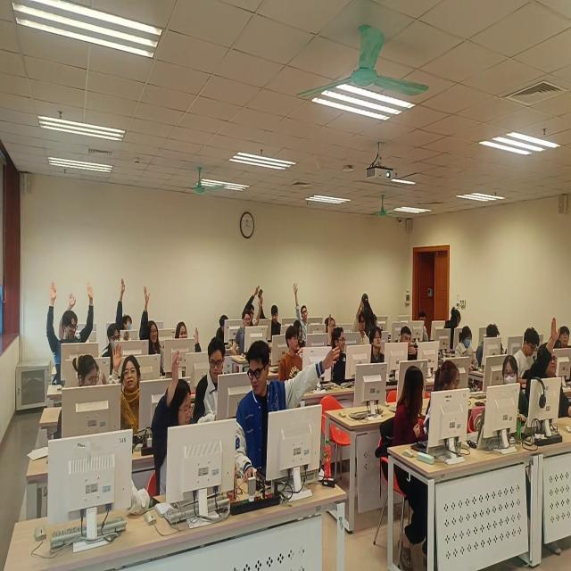

3.5 Dataset Preprocessing
Once the dataset was collected, preprocessing was carried out to make it suitable for training the YOLOv8 model. Data preprocessing is an important step because it improves data quality and ensures compatibility with the deep learning model.
The preprocessing activities included:
- Verifying image annotations.
- Organizing the dataset into the required directory structure.
- Checking the correctness of class labels.
- Splitting the dataset into Training, Validation, and Testing sets.
- Exporting the dataset in YOLO format.
The dataset was divided into separate subsets to ensure that the model was trained and evaluated on different data.
The final dataset consisted of separate folders for training, validation, and testing along with a YAML configuration file containing the class names and dataset paths required by the YOLOv8 framework.
Figure 4.1 Dataset folder structure
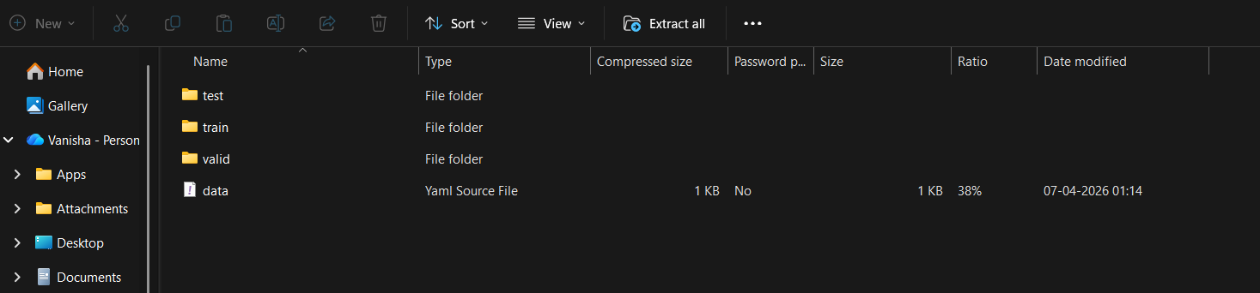
4.2 Dataset Management using Roboflow
Roboflow was used as the primary platform for dataset management and preprocessing. It provides a user-friendly interface for organizing image datasets and exporting them in formats compatible with various deep learning models.
Using Roboflow, the dataset was reviewed to ensure that all annotations were correctly labelled. The platform also simplified dataset organization and export in YOLOv8 format.
The major advantages of using Roboflow during the internship included:
- Easy dataset visualization.
- Annotation verification.
- Automatic dataset organization.
- Export support for YOLOv8.
- Efficient dataset version management.

Figure 4.3 Roboflow project workflow

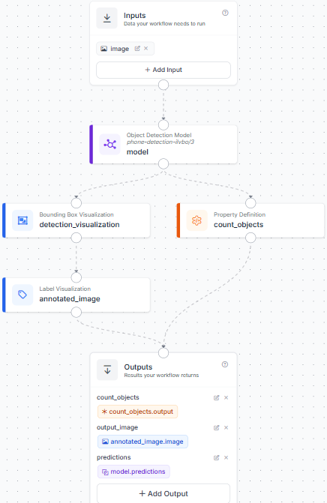
4.4 Development Environment Setup
After preparing the dataset, the next step was setting up the development environment required for model training.
The implementation was carried out using Google Colab, a cloud-based platform that provides free GPU support for deep learning applications. Google Colab eliminated the need for high-end local hardware and significantly reduced the time required for training the model.
The project environment was configured by installing the required Python libraries, including:
- Ultralytics
- OpenCV
- NumPy
- Matplotlib
- Pandas
The dataset was stored in Google Drive and connected to Google Colab to allow access during model training and testing.
Figure 4.5 Google Colab Notebook & Installing packages
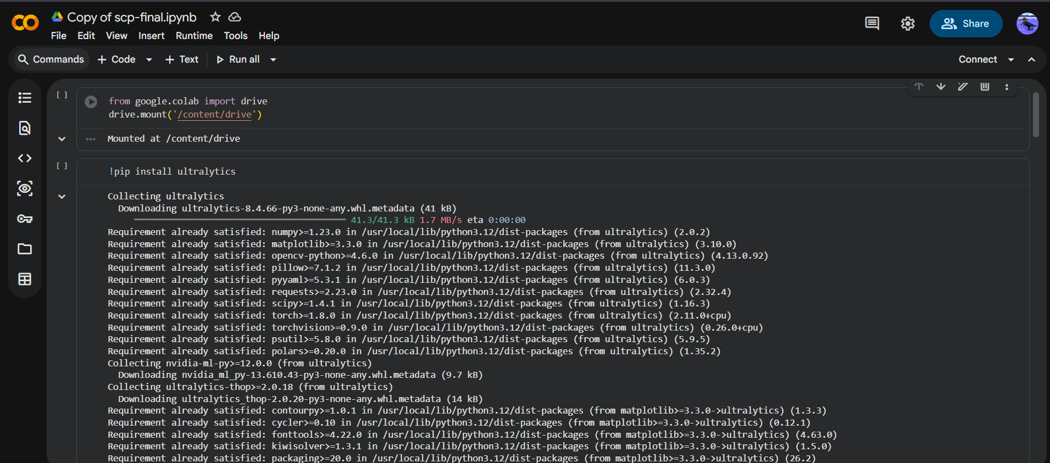5.1 Implementation using YOLOv8
After successfully setting up the environment, the YOLOv8 framework was installed and configured for object detection.
The implementation process involved loading the pretrained YOLOv8 model and customizing it for classroom behaviour detection. The pretrained weights enabled the model to learn faster and achieve better performance compared to training entirely from scratch.
The dataset configuration file (YAML) was used to define:
- Dataset location
- Number of behaviour classes
- Behaviour class names
- Training and validation paths
The model was then initialized using the pretrained YOLOv8n architecture and prepared for training.
Figure 5.2 Training command
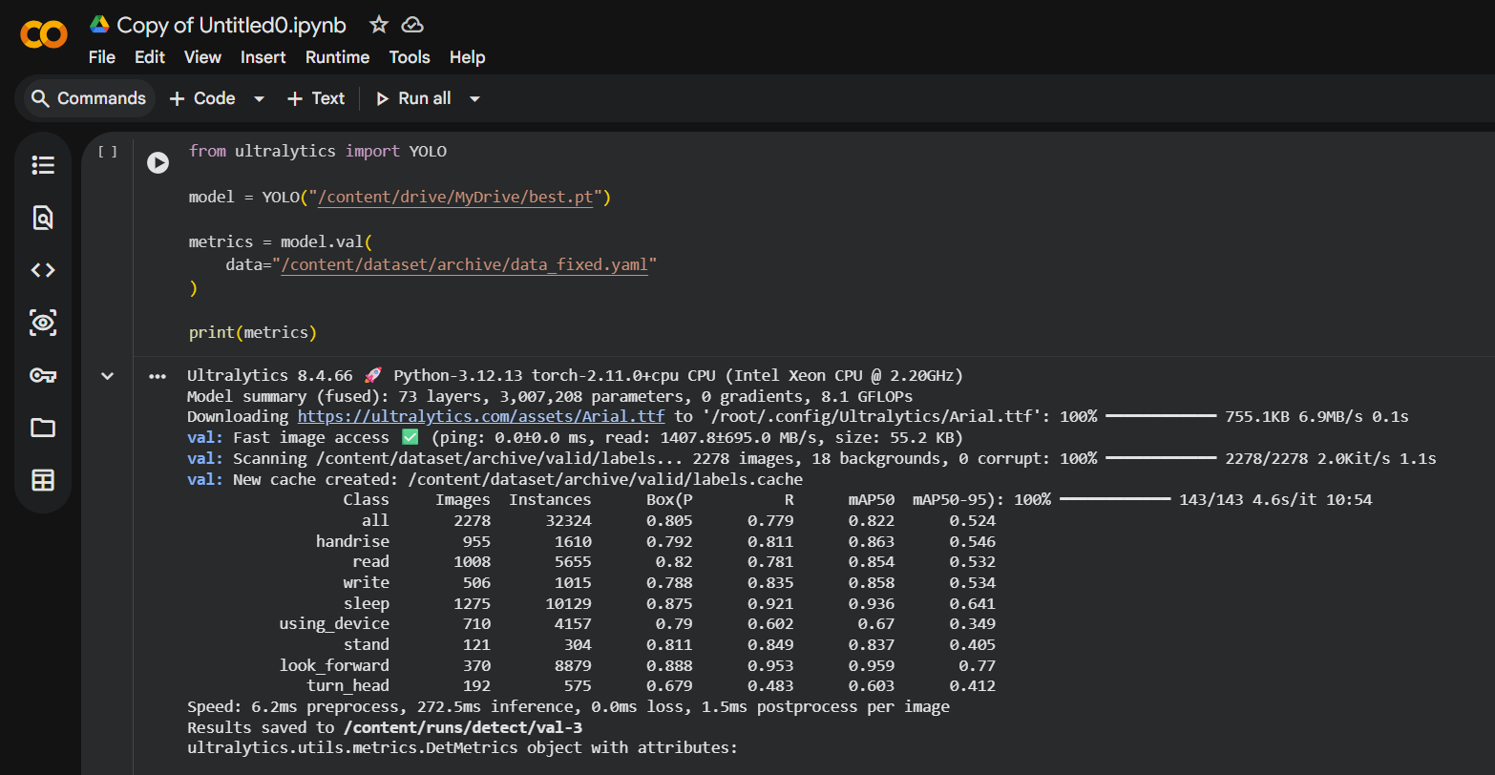5.3 Model Training
The training phase was one of the most important stages of the internship. During this stage, the YOLOv8 model learned to identify different classroom behaviours from annotated images.
The training process was performed using Google Colab GPU, which significantly improved training speed. The model was trained using the prepared classroom behaviour dataset for multiple epochs while continuously monitoring its learning performance.
Throughout the training process, the following metrics were observed:
- Training Loss
- Validation Loss
- Precision
- Recall
- Mean Average Precision (mAP)
The training graphs generated after every epoch helped in understanding whether the model was learning correctly or suffering from overfitting or underfitting.
The best-performing model weights were automatically saved and later used for testing on unseen classroom images and videos.
The successful completion of the training phase demonstrated that the YOLOv8 model had effectively learned to recognize the defined classroom behaviours and was ready for performance.
Figure 5.4 results.png
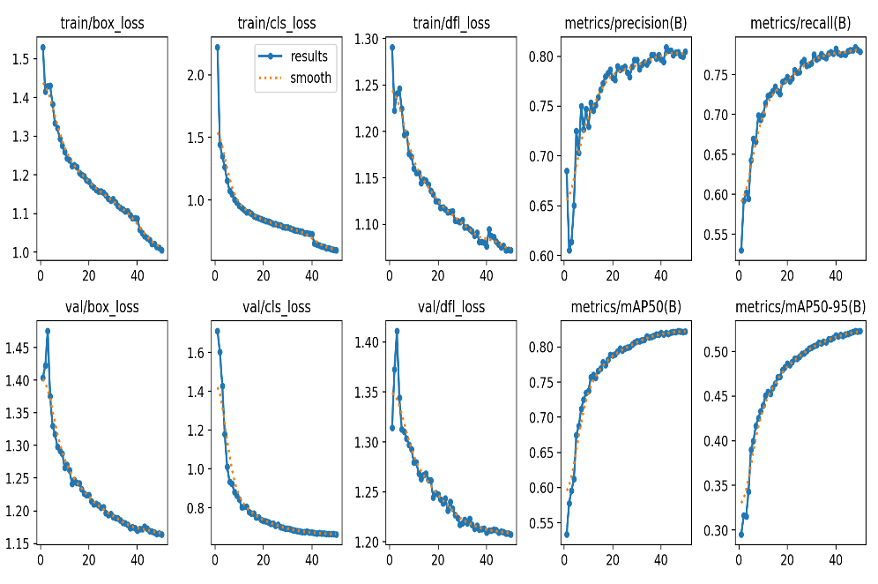
Figure 5.5 Confusion Matrix
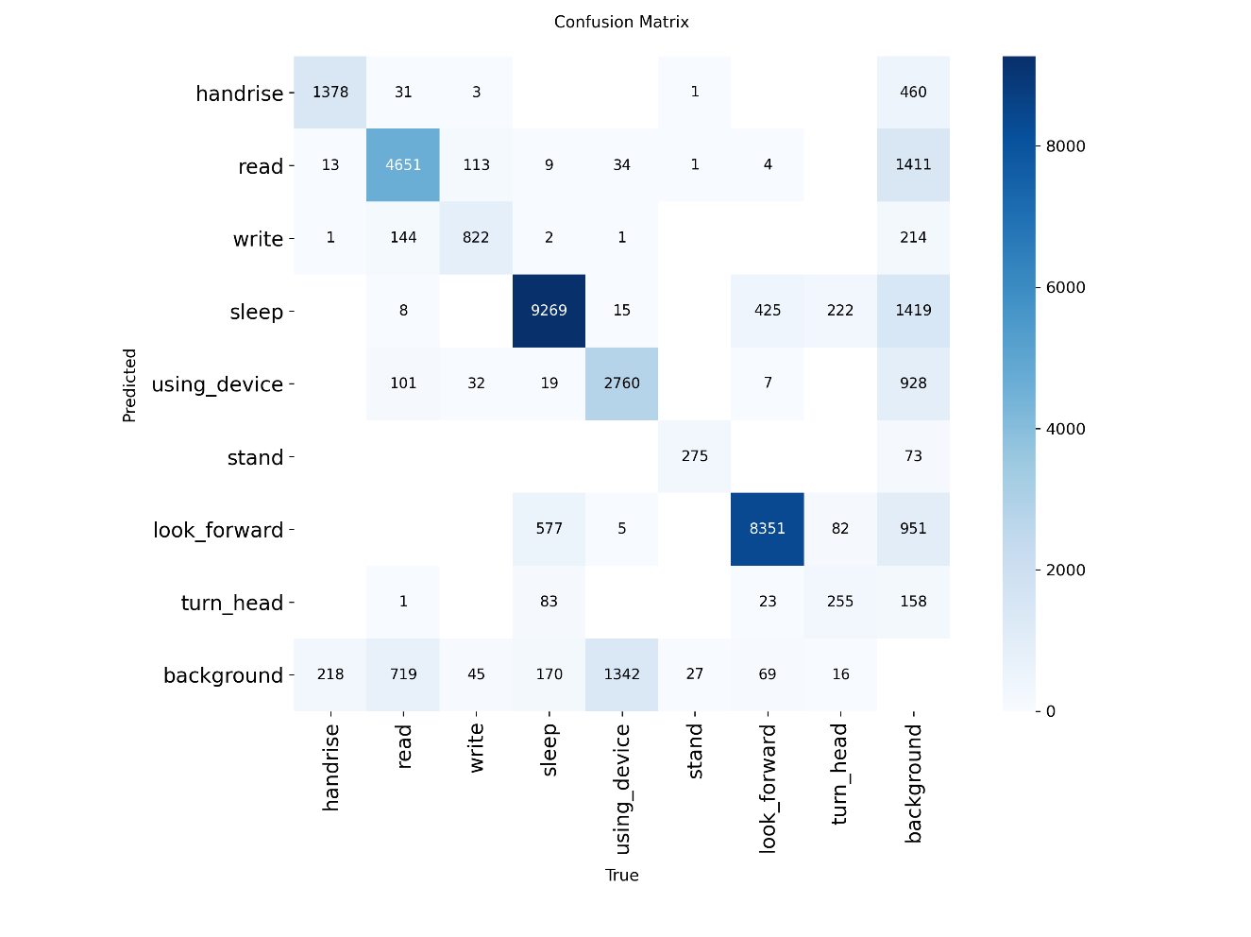

Figure 6.1 F1 Curve
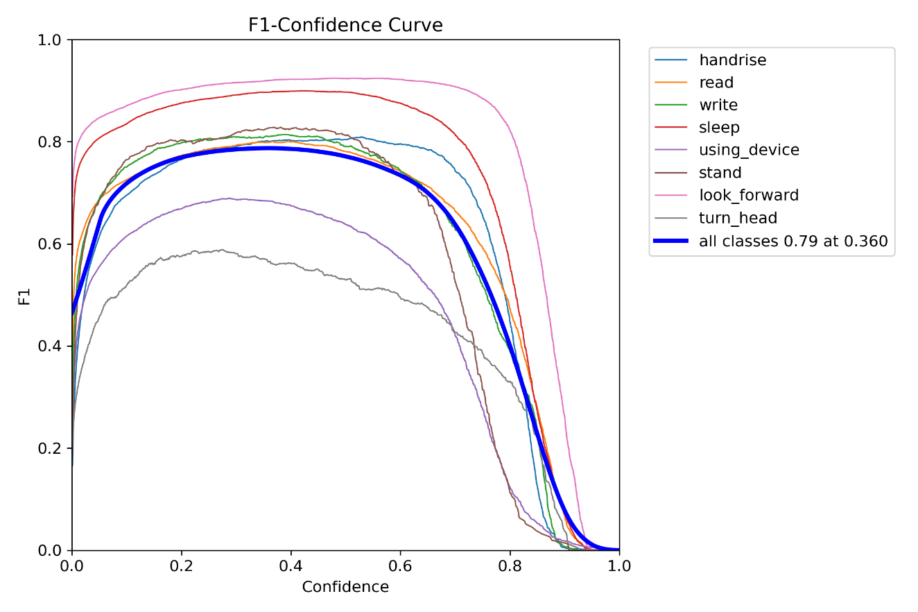
Figure 6.2 PR Curve
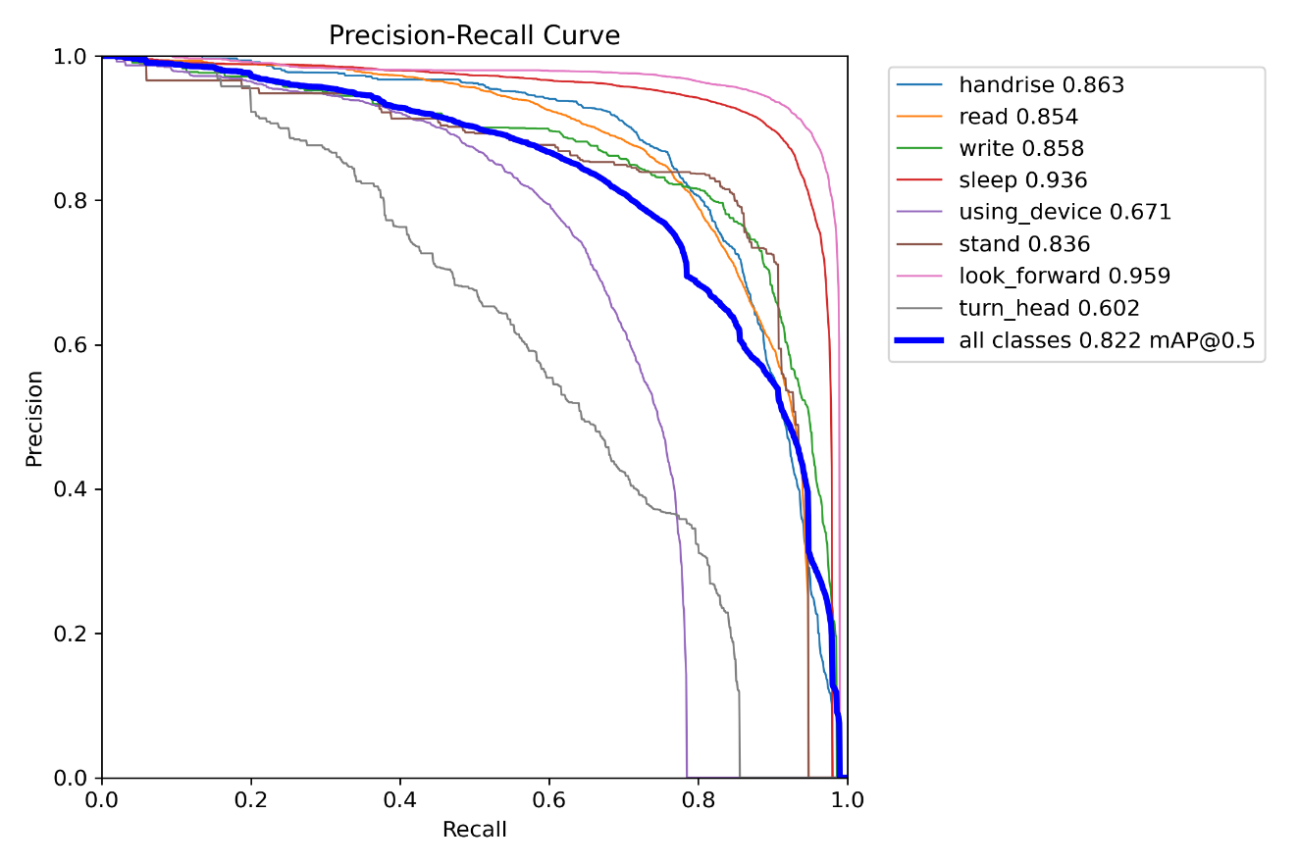

Figure 6.3 R Curve
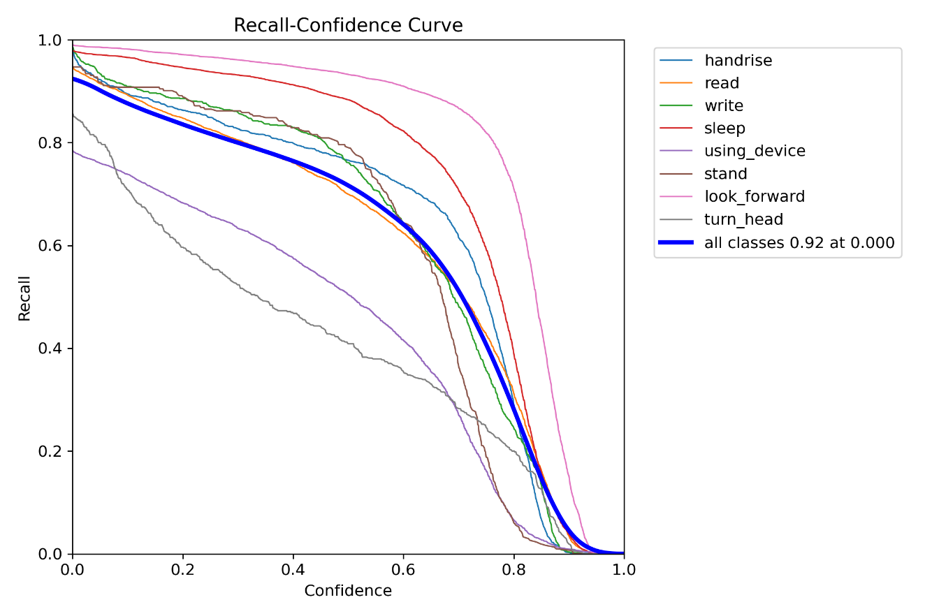
Figure 6.4 P Curve
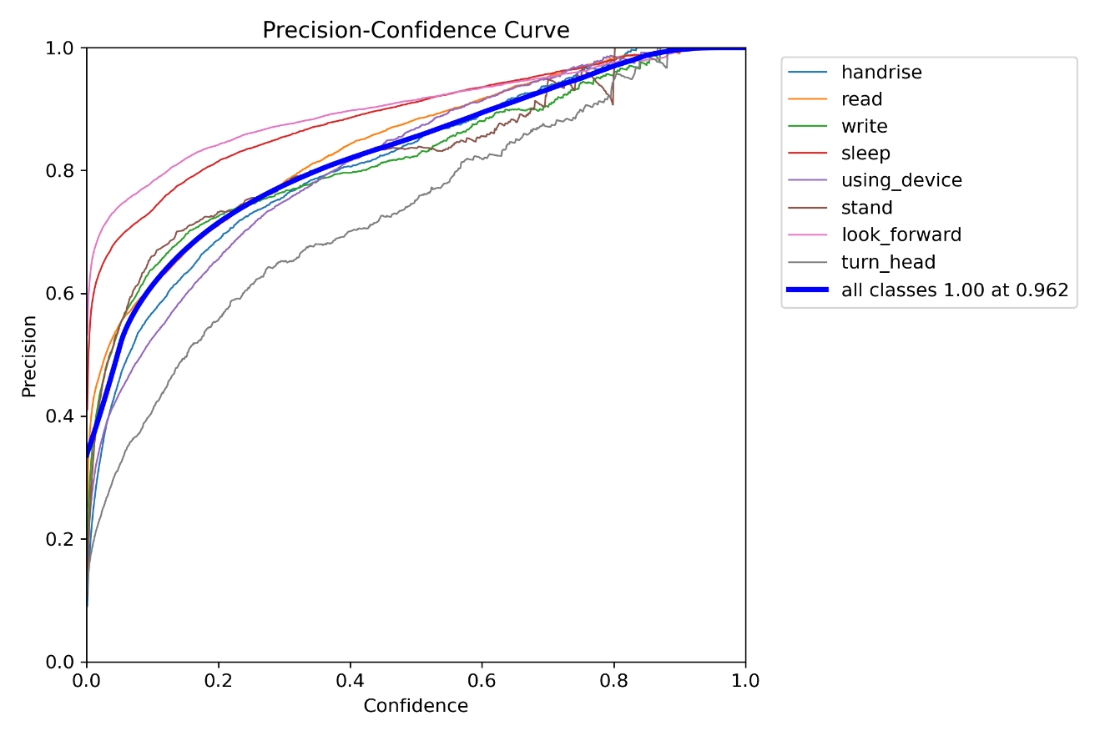

6.5 Model Validation
After completing the training process, the trained YOLOv8 model was validated using the validation dataset to evaluate its learning performance. Validation is an essential step in deep learning because it measures how well the trained model performs on unseen data and helps determine whether the model has generalized effectively.
Several performance metrics were analysed during validation, including Precision, Recall, Mean Average Precision (mAP@50), and Mean Average Precision (mAP@50–95). These metrics provided a comprehensive understanding of the model's ability to accurately detect and classify different classroom behaviours.
The validation results indicated that the model was able to identify the predefined classroom behaviour classes with good accuracy. The validation process also helped monitor the learning progress throughout the training phase and ensured that the model did not suffer from significant overfitting. The best-performing model weights obtained during validation were saved automatically and used for the testing phase.

7.1 Testing and Behaviour Detection
After successful validation, the trained model was tested using unseen classroom images and videos to evaluate its real-world performance. Testing was carried out using the best model weights generated during training.
The testing process involved providing classroom images and recorded videos as input to the trained YOLOv8 model. The model analysed each frame and detected different classroom behaviours by drawing bounding boxes around students along with the corresponding behaviour labels and confidence scores.
The developed system successfully detected multiple classroom behaviours, including:
- Hand Raise
- Reading
- Writing
- Sleeping
- Standing
- Looking Forward
- Using Device
- Turning Head
The testing phase demonstrated that the model was capable of detecting multiple students simultaneously and classifying their behaviours with satisfactory accuracy. The generated output images and videos confirmed the effectiveness of the trained model in classroom monitoring applications.
Figure 7.2 Prediction Image
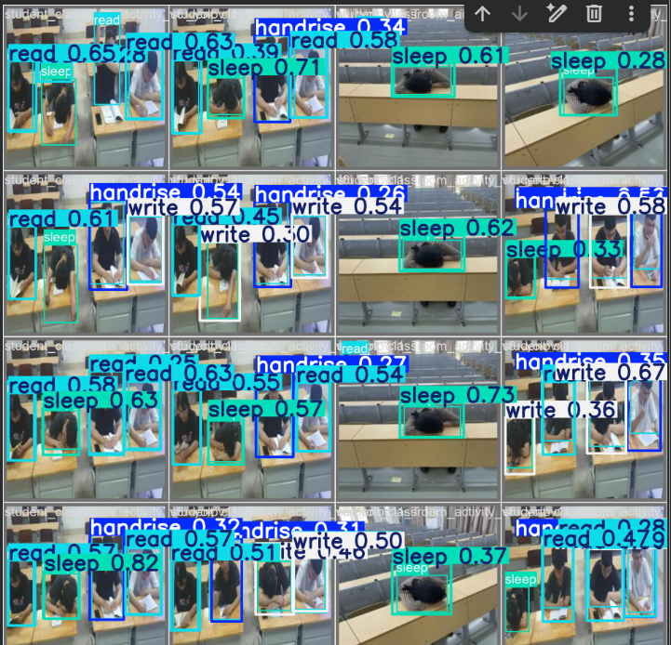
Figure 7.3 Video Detection Screenshot
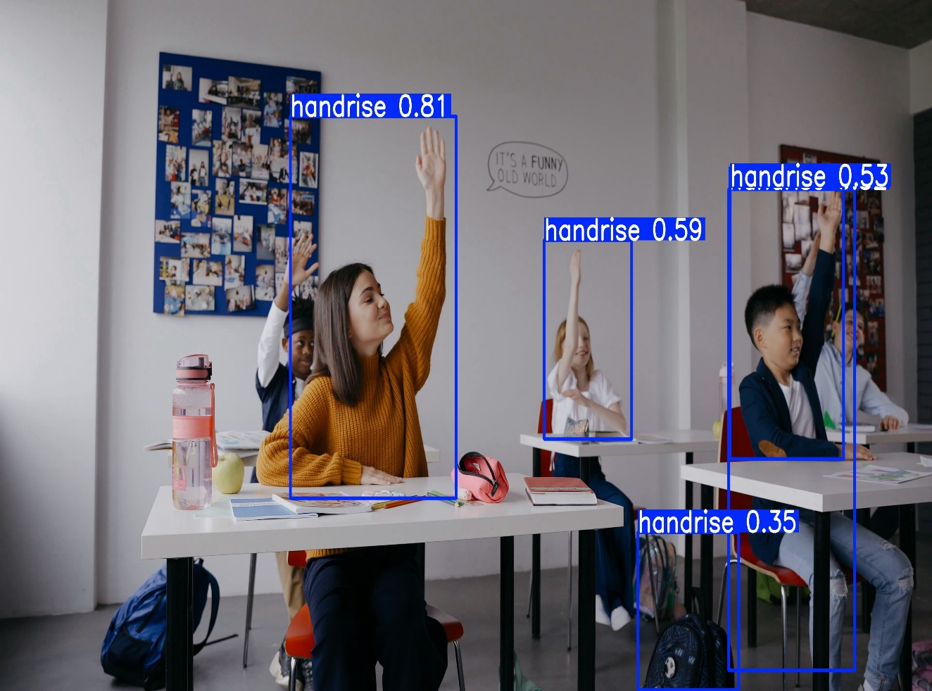7.4 Behaviour Counting and Analysis
In addition to behaviour detection, the project also included a behaviour counting mechanism to analyse the frequency of different student activities detected during classroom sessions.
The developed system counted the occurrences of each detected behaviour while processing classroom videos. This feature provides useful statistical information regarding classroom engagement and student participation. The generated counts can assist teachers in understanding overall classroom behaviour and identifying patterns over time.
The behaviour counting module demonstrated how Computer Vision can be extended beyond object detection to provide meaningful analytics for educational environments. This feature highlights the potential of Artificial Intelligence in supporting data-driven classroom management.
Figure 7.5 Behaviour count output
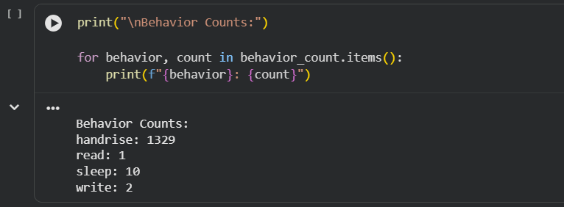
8.1 Performance Evaluation
The performance of the developed Smart Classroom Behavior Detection system was evaluated using standard object detection metrics.
The trained YOLOv8 model demonstrated encouraging performance during testing and was able to detect classroom behaviours with good accuracy. Performance evaluation was based on the following metrics:
- Precision
- Recall
- Mean Average Precision (mAP@50)
- Mean Average Precision (mAP@50–95)
The results obtained during evaluation indicated that the model effectively recognized classroom activities under different scenarios. The use of pretrained YOLOv8 weights and a properly prepared dataset contributed significantly to the overall detection performance.
The successful evaluation confirmed that the developed model is suitable for automated classroom behaviour detection and can serve as a foundation for future intelligent monitoring systems.

8.2 Challenges Faced
During the internship, several practical challenges were encountered while implementing the project. These challenges provided valuable learning opportunities and enhanced my problem-solving skills.
Some of the challenges faced during the internship included:
- Understanding the working principles of the YOLOv8 object detection framework.
- Preparing and organizing the dataset in the required YOLO format.
- Managing large datasets during preprocessing and training.
- Configuring the development environment and required software libraries.
- Handling training errors and dependency-related issues in Google Colab.
- Improving model performance through appropriate training parameters.
- Testing the model on different classroom images and videos to ensure consistent detection accuracy.
Each challenge was addressed through continuous learning, experimentation, and guidance from available documentation and technical resources. Successfully overcoming these challenges significantly improved my understanding of Artificial Intelligence and Computer Vision.

8.3 Skills Acquired
The internship provided an opportunity to develop both technical and professional skills.
Technical Skills
- Python Programming
- Computer Vision
- Deep Learning
- Object Detection using YOLOv8
- OpenCV
- Roboflow
- Google Colab
- Dataset Preparation
- Model Training and Evaluation
- GitHub Version Control
Professional Skills
- Problem Solving
- Technical Documentation
- Time Management
- Independent Learning
- Analytical Thinking
- Communication Skills
- Presentation Skills
The combination of these technical and professional skills has strengthened my overall competency and prepared me for
future academic and industrial projects.
8.4 Learning Outcomes
The internship at Bharat Electronics Limited provided valuable practical exposure to the implementation of Artificial Intelligence in real-world applications.
Through this internship, I gained a deeper understanding of Computer Vision, object detection techniques, dataset preparation, model training, and performance evaluation. I also learned how to use modern AI development tools such as Google Colab, Roboflow, OpenCV, and the Ultralytics YOLOv8 framework.
The project enhanced my programming skills, improved my confidence in implementing deep learning models, and strengthened my ability to solve technical problems systematically. Working on an industrial project also helped me understand professional software development practices, documentation standards, and the importance of continuous learning in rapidly evolving technologies.
Overall, the internship was an enriching experience that significantly contributed to my technical growth and prepared me for future opportunities in Artificial Intelligence, Machine Learning, and Computer Vision.

8.5 Summary of Work Progress
The internship at Bharat Electronics Limited provided an excellent opportunity to apply theoretical knowledge in a practical environment. Throughout the internship, I successfully completed all phases of the project, including understanding the problem statement, dataset preparation, model development, training, validation, testing, behaviour analysis, and performance evaluation.
The project titled "Smart Classroom Behavior Detection using YOLOv8" demonstrated the practical application of Artificial Intelligence and Computer Vision in educational environments. The internship not only improved my technical knowledge but also enhanced my confidence, analytical thinking, and professional skills, making it a valuable learning experience.

Result
During the internship, the Smart Classroom Behavior Detection using YOLOv8 project was successfully completed. After training the model, it was tested using classroom images and videos to check whether it could correctly identify different student behaviours.
The trained model was able to detect all eight behaviour classes included in the dataset: Hand Raise, Reading, Writing, Sleeping, Standing, Looking Forward, Using Device, and Turning Head. During testing, the model identified multiple students in a single image and displayed the detected behaviour using bounding boxes and labels.
The model was evaluated using performance metrics such as Precision, Recall, and Mean Average Precision (mAP). These results showed that the model was able to learn the behaviour patterns effectively and perform well on the testing data. The training graphs, confusion matrix, and prediction outputs generated during model training are included in the Work Progress section of this report.
The trained model was also tested on classroom videos. It successfully detected different student behaviours frame by frame and generated behaviour counts based on the detected activities. This showed that the system can be used not only for image detection but also for analysing classroom videos.
Overall, the project achieved the objectives that were planned at the beginning of the internship. Along with completing the project, I gained practical experience in dataset preparation, model training, testing, and analysing the performance of a deep learning model. This internship also helped me understand how Computer Vision can be used to solve real-world problems in the education field.

Table 4.1: Performance Summary
Parameter | Result
Model Used | YOLOv8n
Programming Language | Python
Platform | Google Colab
Number of Classes | 8
Image Detection | Successful
Video Detection | Successful
Behaviour Counting | Implemented
The overall results of the project were satisfactory and matched the expected objectives. The model was able to detect different classroom behaviours with good accuracy and produced reliable results during testing. The experience gained from this project improved my understanding of Artificial Intelligence, Deep Learning, and Computer Vision and gave me confidence in working on similar projects in the future.

Conclusion
The internship at Bharat Electronics Limited (BEL), Bengaluru, was a valuable learning experience for me. It helped me understand how the concepts I learned in college can be applied to solve practical problems using Artificial Intelligence and Computer Vision.
During the internship, I worked on the project "Smart Classroom Behavior Detection using YOLOv8." From preparing the dataset to training, testing, and evaluating the model, I gained hands-on experience in every stage of the project. I also learned how to use tools such as Python, Google Colab, OpenCV, Roboflow, and YOLOv8, which are widely used in AI and computer vision projects.
One of the biggest learning experiences during this internship was understanding that developing an AI model involves much more than just writing code. Preparing the dataset, fixing errors, testing different approaches, and analysing the results were equally important parts of the project. Working through these challenges improved my problem-solving skills and gave me more confidence in working on real-world projects.
Apart from technical knowledge, I also learned the importance of planning, documentation, and continuous learning while working on an engineering project. This internship has motivated me to explore Computer Vision and Deep Learning further and has strengthened my interest in the field of Artificial Intelligence and Machine Learning.
Overall, the internship was a rewarding experience that enhanced both my technical and professional skills. I believe the knowledge and practical experience gained during this internship will be useful in my future academic projects and career.

Reference

Books
[1] Stuart Russell and Peter Norvig, Artificial Intelligence: A Modern Approach, 4th Edition, Pearson, 2021.
[2] Rafael C. Gonzalez and Richard E. Woods, Digital Image Processing, 4th Edition, Pearson, 2018.
Websites
[3] Ultralytics Documentation – https://docs.ultralytics.com
[4] OpenCV Documentation – https://opencv.org
[5] Roboflow Documentation – https://docs.roboflow.com
[6] Python Official Documentation – https://www.python.org
[7] Kaggle – Smart Classroom Behaviour Dataset – https://www.kaggle.com

